Smart Traffic System with Green Time optimization using Fuzzy logic

Bharathwaj Murali

School of Computer Science and Engineering

Vellore Institute of Technology, Chennai,

[bharathwajmurali3@gmail.com](mailto:bharathwajmurali3@gmail.com)

Dr. R.Radha

School of Computer Science and Engineering, Associate Professor

Vellore Institute of Technology, Chennai,

rradha@vit.ac.in

Vishnu Prasad

School of Computer Science and Engineering

Vellore Institute of Technology, Chennai,

mmvishnu24@gmail.com

Kavin A.K

School of Computer Science and Engineering

Vellore Institute of Technology, Chennai,

www.iamachampion@gmail.com

***Abstract* - Traffic Congestion has been a very big issue due to the large number of vehicles being utilized in cities. It is necessary to control the number of vehicles getting in and out of the crossing such that the city traffic congestion decreases in an efficient way. In this paper, we try to improvise the timings of green signals using fuzzy logic based on the number of vehicles, speed limit, and length of the crossing. We find out the number of vehicles using computer vision dynamically. We validate our system in two different locations in Chennai against the manual green signal duration that is set manually and we prove that our method improves the waiting time significantly.**

*Keywords* – Deep Learning, Computer Vision, Fuzzy Logic, Internet of Things, Intelligent traffic management

**1. Introduction**

Traffic congestion on roads has been a huge issue in metropolitan cities ever since the popularity of motor vehicles has increased. Traffic congestion occurs when there is a large number of vehicles that are unable to drive to their respective destinations as the vehicles ahead of them have stopped. This is also called the saturation process. Situations such as accidents or sudden braking of a car in a smooth flow of heavy traffic, roadside constructions, traffic signals, and vehicles waiting to turn at an intersection can cause traffic congestion. In countries like India, there is an estimated annual loss of approximately Rs 60,000 crores due to congestion(fuel wastage, traffic maintenance, etc). Traffic Congestion is very common due to the large number of vehicles manufactured and bought by the people. It's a challenge for controlling the vehicles in and out of the crossing in a way that overall traffic congestion decreases in an efficient way. We are trying to Prioritize moderate traffic conditions, Provide a smart lighting system that reserves renewable energy sources, Offer safe and punctual public transportation, Optimize road networking systems, by building IoT, enabling quick and better communication systems.

SECTION 2: The Related works explain the literature survey of the existing works which we have gone through.

SECTION 3: The Proposed system explains our idea and its implementation in detail.

SECTION 4: The Experiments and results heading explain the experiments we have done and the results which we have obtained.

SECTION 5: The Conclusion Explain What we have concluded based on the project.

SECTION 6: The Future works explain how we can improve this project in the future with different ideas and approaches.

SECTION 7: References heading contains the works we have referend.

**2. RELATED WORK**

In [1], the authors analyze multiple factors to be considered for selecting optimal green time in managing the traffic. In [2], the authors find that start-up lost time needs to be taken into consideration which helps how quickly the vehicles move out of the intersection depending on the time in which the vehicles start to accelerate and move. Since this always takes some time to happen it is important to look into this parameter and decide the optimal value. This paper finds the optimal value by giving a brief analysis. It's important to take into account the green time optimization [3] parameters, this paper considers the number of phases, the queue length of each phase, and the maximum queue acceptable for a given phase. Authors give an idea of the saturation headway (in seconds) [4] which is important to be known because it helps in estimating the capacity for example if the saturation headway is 4 seconds, authors say that 3600 seconds per hour divided by 4 gives 900 vehicles per hour per lane. In [5], authors have considered a new angle of approaching the green signal timing where they produced and named it effective green time based on some of the changes in the actual green lights, the changes in the actual yellow lights, and the changes in the actual red clearance lights which is subtracted by the start-up lost time and the clearance lost interval (Values are in seconds).In [6], The authors analyze the daily traffic volume at various mid-blocks in Chennai. The authors proposed a traffic light switching and traffic density calculation with the help of video processing over VANET. In [7], the authors have presented a system of taking pictures from the traffic pole with the empty road as a reference image. They also compute the volume of the traffic on the road and control the traffic in a smart way. In [8], the system works on the principle of IoT and related algorithms. With the help of an ultrasound sensor placed on the roadsides, they count the number of vehicles, and traffic lights are controlled accordingly. This paper [9] is based on a hybrid approach that is a combination of centralized and decentralized approaches for optimizing traffic flow on roads and also the developed system connects to nearby rescue departments with the centralized server as well as extracts useful information for future road planning. The authors improve the current traffic management system with the help of IoT-based concepts[10]. The ultrasonic sensors are fixed on each lane. They have used three types of sensors: High, Medium, and Low. High is sending on 1st priority Medium on 2nd and Low on 3rd priority respectively. The data is collected from the sensors and sent to the system. The traffic density is found, and the average waiting time is figured out. In this method[11], they are using RFID to compute the density of the traffic on both sides of the road. This will help in getting the direction of the vehicles and help to track them and also find the stolen vehicles. The traffic signal lights are changed based on the density of the traffic detected by the RFID placed on either side. This paper[12] proposed to develop traffic signal timing plans. By using cluster analysis time-of-day was identified with the help of historical data with data mining techniques. Authors[13] mainly focus on implementing a system in which vehicle detection and counting are done from a video or camera sensor. In this paper, the system uses the camera as an input sensor which provides real-time traffic data and is implemented using BeagleBoard and AVR microcontroller. Video from the camera is processed using (PCA) Principal Component Analysis.PCA is used for analyzing and classifying the object on a video frame for detecting vehicles. The DCSP method is used here to identify the duration of each traffic signal, which is based on the number of vehicles in each lane. In [14], using a variety of technologies like VANET and video processing they were able to get the values and perform the required calculations. This paper [15] discusses a system that controls the traffic lights with the help of a Microcontroller PIC16F877A, LCD display, IR sensor, and XBee transceivers.

**3. PROPOSED SYSTEM**

**3.1 Initialization Phase**

To combat the mentioned issues, we propose a smart traffic management system that takes into consideration the various variables that affect the flow of traffic and propose a method by which can dynamically change the traffic lighting system to optimize the traffic signal. To do this task we must first recognize the variables that can help us understand the situation on the road so that we can calculate and provide a proper green light time. The variables that we have taken into consideration are speed limit, the distance between two crossings, number of cars at a particular time, number of 2 or 3 wheelers at a particular time, and the number of large vehicles( buses and trucks) at a particular time.

During the implementation, the size of the road and speed limit are constants and can hence be manually added during the beginning of setup and the dynamic values of no of cars, bikes, and buses are calculated using an object detection algorithm called YOLOv3. YOLOv3 is an object detection algorithm that is popular for its speed and accuracy. The YOLOv3 model is trained to detect these 3 classes of objects and provides the no of these objects which has been detected to our main calculator, the calculator here implements the fuzzy logic method to predict the output(no of seconds of green light) and the microcontroller uses this to effectively to regulate the traffic lights and decrease congestion.

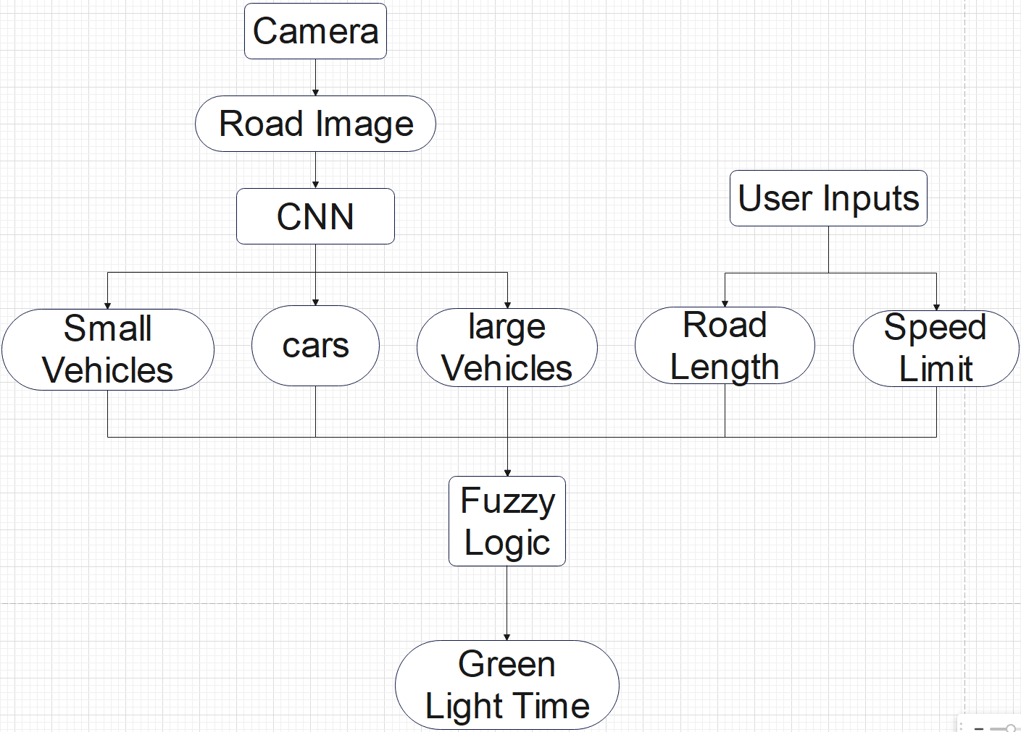

Fig. 1 System architecture

**3.2 Fuzzifier**

We represent our variables as fuzzy linguistic variables used to represent qualities spanning a particular spectrum which we have taken into account as input variables are the number of two / three wheelers [low, medium, high] number of cars [low, medium, high], number of large vehicles [low, medium, high], the speed limit of the particular road [low, medium, high], the distance between two crossings [low, medium, high] are the input variables for the fuzzifier. In the case of the output variable, the fuzzy linguistic variable we have taken is the green signal time. We quantified the certainty of our input and output space of linguistic values (low, medium, high) and formed the membership functions.

With the membership functions formed we will be able to get the degree of truth or membership for every input variable. For all input and output fuzzy variable values, the Triangular membership function has been defined.

We have represented the yellow line as low value, green line as middle value, and red line as high value.

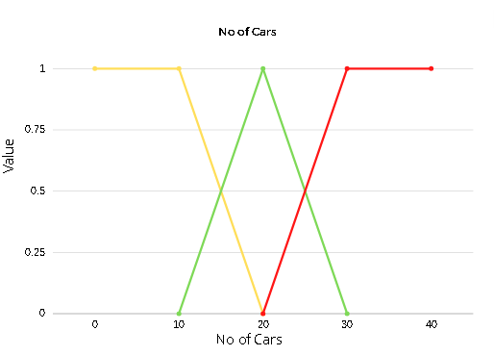

Fig. 2 Membership function for input parameter number of cars vs the value of fuzzification. Up to 10 cars, is considered absolutely low, 10 - 20 low - mid, 20 - 30 mid - high, and > 30 is considered absolutely high.

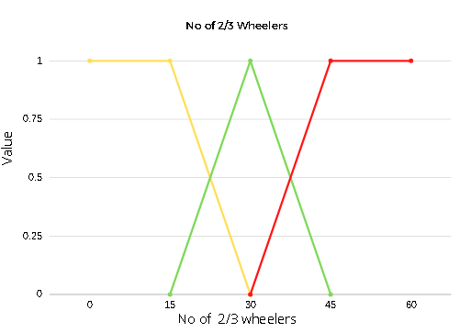

Fig. 3 Membership function for input parameter number of

2/3 wheelers vs the value of fuzzification. Up to 15, is considered absolutely low, 15 - 30 low - mid, 30 - 45 mid-high, and > 45 is considered absolutely high.

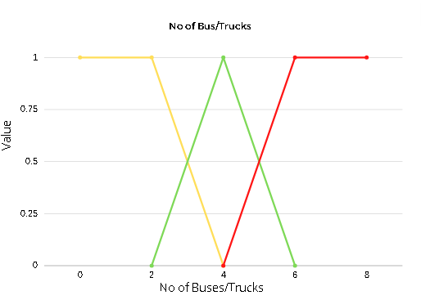

Fig. 4 Membership function for input parameter number of Bus vs the value of fuzzification. Up to 2, is considered absolutely low, 2 - 4 low - mid, 4 - 6 mid - high, and > 6 is considered absolutely high.

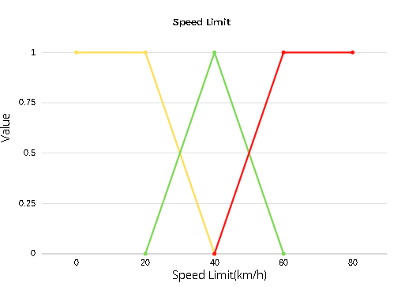

Fig. 5 Membership function for input parameter Speed Limit vs the value of fuzzification. Up to 20 km/hr, is considered absolutely low, 20 - 40 km/hr low - mid, 40 - 60 km/hr mid - high, and > 60 km/hr is considered absolutely high.

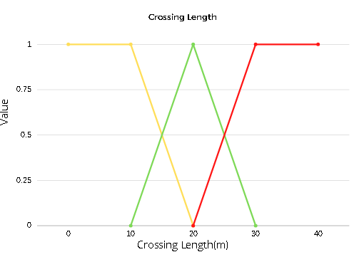

Fig. 6 Membership function for input parameter Crossing Length vs the value of fuzzification. Up to 10 m, is considered absolutely low, 10 - 20 low - mid, 20-30 mid - high, and > 30 is considered absolutely high.

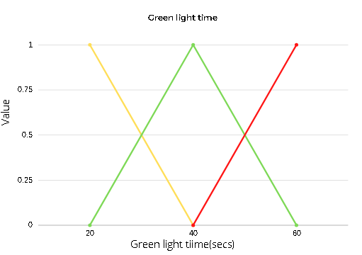

Fig. 7 Membership function for output parameter Green signal time vs the value of fuzzification. Upto 20 sec, is considered absolutely low, 20 - 40 low - mid, 40 - 60 mid - high, and > 60, is considered absolutely high.

**3.3 Fuzzy rules**

A predefined set of rules which are calculated based on the data we have obtained based on the existing auto-enabled traffic signals and analyzing them on the amount of time it usually takes for different amounts of vehicles to pass. Based on the rules we calculate the weights for each green light timing provided (20 sec, 40 sec, and 60 sec) and obtain the weighted average to get the final green light time. Here are a few rules we were able to build based on the reviews we have taken

i) (high(speed limit) \/ high(length between crossing) )\/( low(number of cars) \/ low(number of bikes) \/ low(number of large vehicles) => low(green signal time))

ii) (mid(speed limit) \/ mid(length between crossing)) \/ (mid(number of cars) \/ mid(number of bikes) \/ mid(number of large vehicles)) => mid(green signal time)

iii) (low(speed limit) \/ low(length between crossing)) \/ (high(number of cars) \/ high(number of bikes) \/ high(number of large vehicles)) => high(green signal time)

**3.4 Defuzzifier**

Now we use the weighted average method to a crisp output value from the fuzzy values we have obtained from the fuzzy rules

y∗ = ∑ *µ*(y).y / ∑ *µ*(y)

where y is the variable with the corresponding membership function (20/40/60 sec). *µ*(y) is the respective fuzzy value obtained from the rules y* is the final crip output value (final green signal time in sec).

**4. EXPERIMENTS AND RESULTS**

In order to understand how many seconds of green light is required for different situations so that we can design the rules for calculating the green light time, we have decided to go to various traffic signals and collect data regarding the number of vehicles of each type before the green light and after the green light in case of lesser than ideal green signal time or how much seconds were wasted in case of higher than ideal green signal and then compare it with the amount of green light time provided by our model.

**Table 1: Traffic Signal 1**

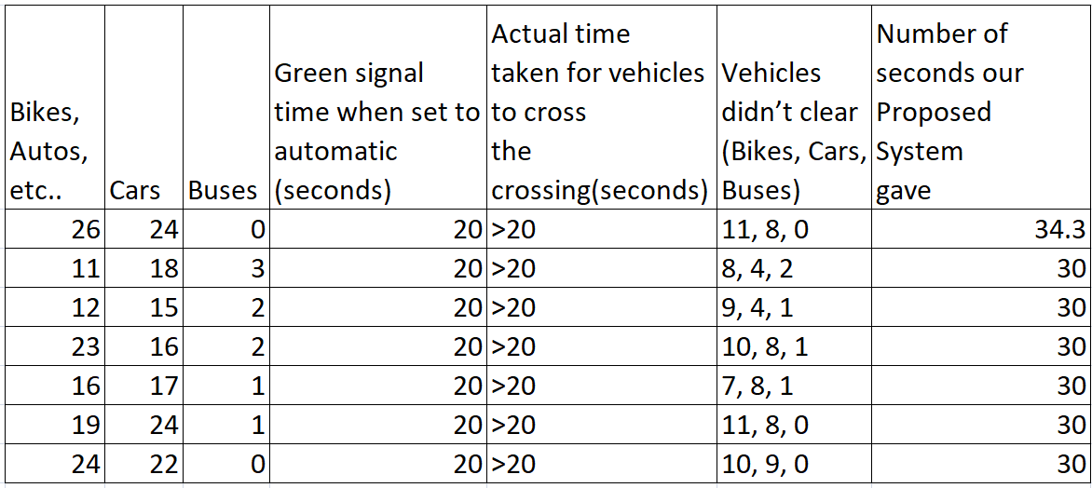

The traffic signal 1 data is taken from the Tidel Park to Besant Nagar and Thiruvanmiyur signals. Here during the time in which we were taking the recordings, we noticed that the time given by the automatic signal was mostly not enough for the vehicles to cross through and hence we have taken the table details accordingly.

**Table 2: Traffic Signal 2**

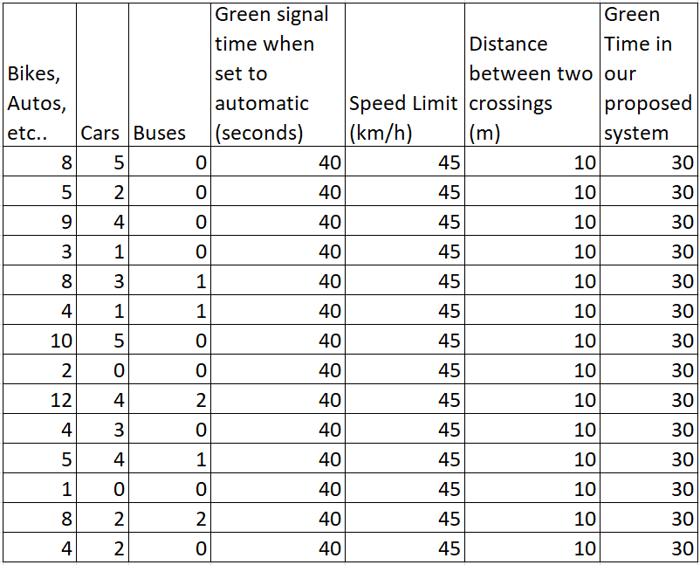

The traffic signal 2 data is taken from Indira Nagar to Thiruvanmiyur. Here while we were surveying the vehicles and the time they have taken for each of them to pass, we have noted that there was a considerable amount of free time observed after the vehicles had passed that the green light was on.

**5. CONCLUSION**

Smart traffic systems are a step forward in making our environment clean and safe for human - life to exist. We are able to save many lives with this smart traffic system as we have trained the model in such a way that fewer false values are provided. The model is also much improved and better when including human interference. Our model was trained with parameters and we set 3 rules for the model to train with so that the model can understand the environment it is in and can proceed with the proper and necessary action. The number of cars present in the traffic, the number of cars left after the green light turns red and the amount of seconds the green light is provided for the vehicles to proceed are all important factors we have taken into consideration to achieve our goal.

**6. FUTURE WORK**

For future works, we feel we could make use of the synchronization process between two or more traffic lights within the same vicinity. We could include the detection of pedestrians for their safety while crossing the road as well as include an emergency option for ambulances as they need to quickly reach their destination when time is of the essence. We could improve the accuracy of the system, by adding more rules during the fuzzy logic implementation.

**7. REFERENCES**

[1] 1 K.Hari Krishna, 2K. Vinay Kumar, 3Dr. Ch. Hanumantha Rao, SIGNAL DESIGN USING WEBSTER’S METHOD (4 Legged Intersection), 1,3K L University, Green Fields, Vaddeswaram, 2College of Engineering, Osmania University, Hyderabad, Indian J.Sci.Res. 17(2): 113-119, 2018

[2] Matsoukis, E. & Efstathiadis, St. (2010). An investigation of the variability of start-up lost times and departure headways at signalized intersections in urban areas. WIT Transactions on the Built Environment. 111. 59-68. 10.2495/UT100061.

[3] Li, Yan & Yu, Lijie & Tao, Siran & Chen, Kuanmin. (2013). Multi-Objective Optimization of Traffic Signal Timing for Oversaturated Intersection. Mathematical Problems in Engineering. 2013. 1-9. 10.1155/2013/182643.

[4]Signalized Intersections: Informational Guide, Published Date : 2004-08-01, Report Number : FHWA-HRT-04-091, URL : <https://rosap.ntl.bts.gov/view/dot/39968>

[5] Traffic Signal Timing Manual, U.S Department of Transport, Chapter 3, URL: [https://ops.fhwa.dot.gov/publications/fhwahop08024/chapter3.htm](https://ops.fhwa.dot.gov/publications/fhwahop08024/chapter3.html)

[6] Senathipathi, Velmurugan & Reddy, T.S. & Errampalli, Madhu & Rao, I.P.. (2005). Traffic operating characteristics and its impacts on air pollution in an urban area-a case study of Chennai, India. 1799-1814.

[7] Vismay Pandit, Jinesh Doshi, Dhruv Mehta, Ashay Mhatre, and Abhilash Janardhan, "Smart Traffic Control System Using Image Processing," IJETTCS, Volume 3, Issue 1, January February 2014

[8]Ankit Dubey, Mayuri Lakhani, Shivansh Dave, Jignesh J. Patoliya, "Internet of Things based Adaptive Traffic Management System as a part of Intelligent Transportation System (ITS)", IEEE 2018.

[9]Sabeen Javaid, Ali Sufian, Saima Pervaiz and Mehak Tanveer, "Smart Traffic Management System Using Internet of Things", IEEE 2018.

[10]. Karan A Shah, Jasmine Jha2, "Improvement of Traffic Monitoring System by Density and Flow Control for Indian Road System Using IoT ".

[11]Anuran Chattaraj, Saumya Bansal and Anirudhha Chandra, An Intelligent Traffic Control System Using Rfid

[12]Zahra Zamani, Mohammad Hossein Saraee, Mahmoud Pourmand ," Application of Data Mining in Traffic Management: Case of City of Isfahan", IEEE 2010.

[13]M Febrian Rachmadi, Faris Al Afif, Wisnu Jatmiko, Petrus Mursanto, Manggala E A, and M Anwar Ma'sum, "Adaptive Traffic Signal Control System Using Camera Sensor and Embedded System", IEEE (2011)

[14] Kanungo, Anurag & Sharma, Ayush & Singla, Chetan. (2014). Smart traffic lights switching and traffic density calculation using video processing. 1-6. 10.1109/RAECS.2014.6799542.

[15] Ghazal, Bilal & Khatib, Khaled & Chahine, Khaled & Kherfan, Mohamad. (2016). Smart traffic light control system. 140-145. 10.1109/EECEA.2016.7470780.